RESOLUTION NO.__________

RE: CERTIFICATE OF APPROPRIATENESS UNDER THE
PROVISIONS OF THE ACT OF THE PENNSYLVANIA
LEGISLATURE 1961, JUNE 13, P.L. 282 (53
SECTION 8004) AND BETHLEHEM ORDINANCE NO.
3952 AS AMENDED.

WHEREAS, it is proposed to replace the existing hanging sign with a new sign on the front of the building, also, to install new way-finding signs on the back of the building and front of the building at 521 E. Fourth Street.

NOW, THEREFORE, BE IT RESOLVED by the Council of the City of Bethlehem that a Certificate of Appropriateness is hereby granted for the work.

Sponsored by: (s)

(s)

ADOPTED BY COUNCIL THIS DAY OF

(s)
President of Council

ATTEST:

(s)
City Clerk

HISTORIC CONSERVATION COMMISSION

CASE # 551 – It is proposed to replace the existing hanging sign with a new sign on the front of the building, also, to install new way-finding signs on the back of the building and front of the building at 521 E. Fourth Street
OWNER/APPLICANT: Rick Cantelmi / Jessie Thompson

The Commission upon motion by Mr. Evans seconded by Mr. Lousch adopted the proposal that City Council issue a Certificate of Appropriateness for the proposed work described herein:
- The proposal to replace the existing hanging sign with a new sign on the front of the building, also, to install new way-finding signs on the back of the building and front of the building at 521 E. Fourth Street was presented by Scott Walker.
- The signs will read “the Yoga loft” in dark brown lettering with a tan circle on a white background as proposed.
- The hanging sign will be 32” x 36” and will hang on the existing bracket. The sign will be fabricated of marine grad plywood. Hanging from the bottom of the sign will be a 32” x 6” sign reading “Use Ace Hardware Entrance”
- The way-findings signs will be 14” x 16.5” and read the same as the hanging sign with directions on how to enter in tan at the bottom of each sign. The way-finding signs will be fabricated of Dibond.
- One of the way-finding signs will be placed to the side of the Ace Hardware entrance, and the other will be located at the rear to the left of the metal exit door. They signs will be attached into mortar joints to limit damage to the brick.
- The proposed motion was unanimously approved.

CU: cu
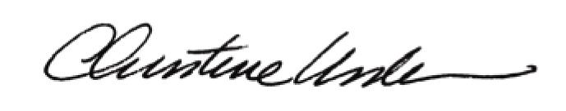

By:

Date of Meeting: May 18, 2015 Title: Historic Officer

